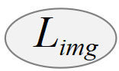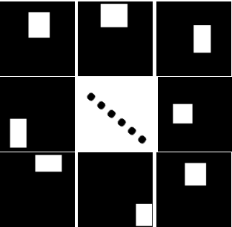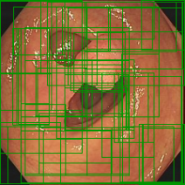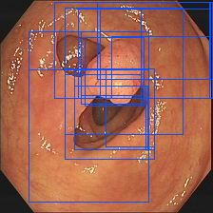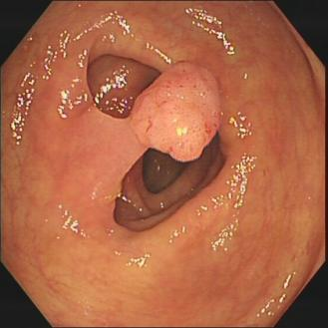

**Section3.2 Cross-referenced module**

Test

Train

Proposals masks **B**

Pseudo segmentation map **P**

Input Image **I**

Backbone

(VGG 16)

**RoI Pooling**

**...**

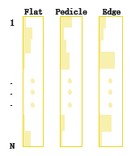

FC1

FC2

FC3

**Section 3.4 Multiple instance branch**



Original Proposals



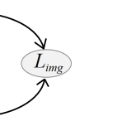



Selective

search

Featurex



**...**

**Section 3.3 Space category module**

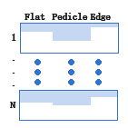

Average &

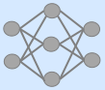



Flatten

Proposals



Segementaion Network（S）



**Post-processing**

**Section 3.5 Dual-threshold Postprocessing Strategy**

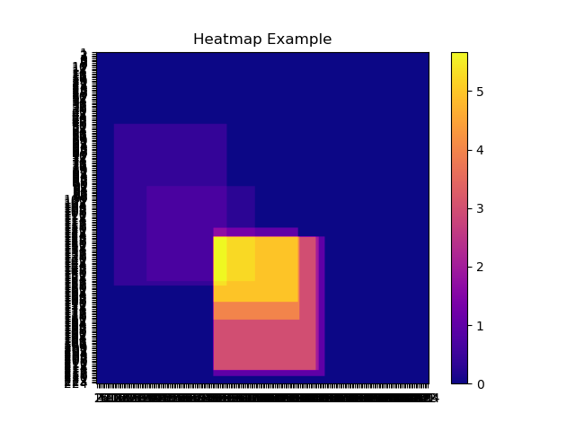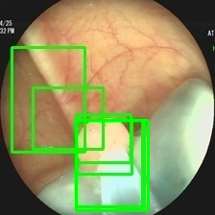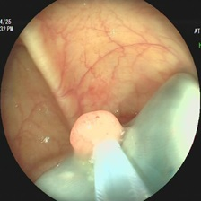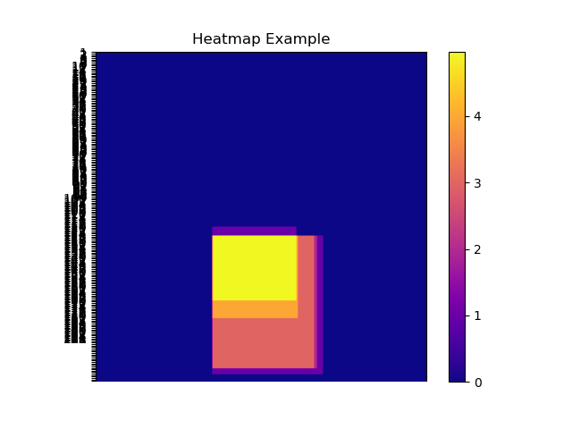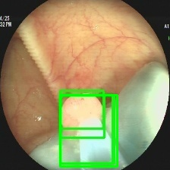

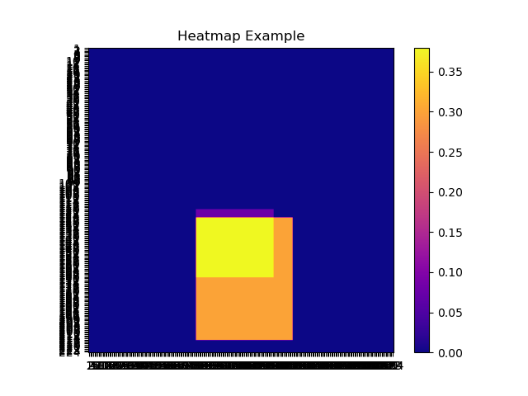



MDNet



Certainty map

( )

Original boxes

(N0)

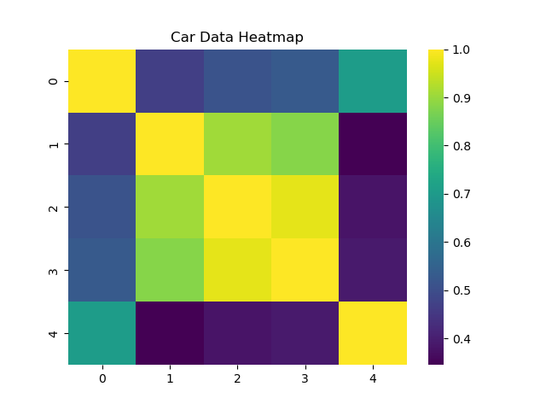

Filter by nms

(N2)

Refined prediction

Pseudo prediction

refinement

Region-certainty

map( )

Original boxes nms filter

Overlap map

(N1×N1)

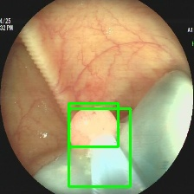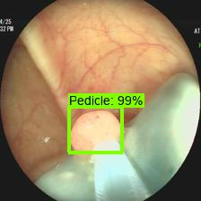

Image

(I)



High-certainty

map

Filter by class

(N1)